Module 2 Lesson 7: Rational Exponents and Graphing Radical Functions (Sections 6.4, 6.8)

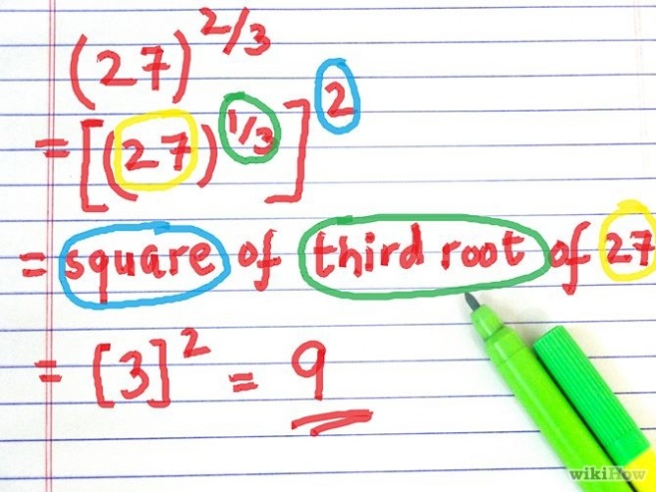

Learning Targets:
I can….
- Write a radical expression in equivalent form $\sqrt[n]{x^{m}}=x^{\frac{m}{n}}$

- Graph square root functions ($y=\sqrt{x}$) and the cube root function $y=\sqrt[3]{x}$ using reflections, translations, and compressions/stretches.

- Restrict the domain of a quadratic function in order to see the square root function.

- State the domain and range of the square root and cube root functions and verbalize any restrictions in the domain

Is there are relationship between fractional exponents and radicals? Use your calculator to complete the following table and see what happens.
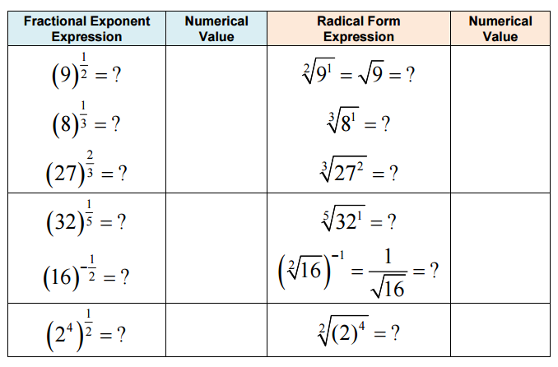
So there is a pattern relating fractional exponent expressions to radical for expressions. Express ${(34)}^{\frac{1}{2}}$ in a radical form and $\sqrt[3]{{(3)}^{2}}$ as a fractional exponenet.

Review of Rational Exponent Rules:

Let m and n represent rational numbers. Assume that no denominator equals 0.
Property Example
$a^{m}∙a^{n}=$

$${(a^{m})}^{n}=$$

$${(ab)}^{m}=$$

$$a^{-m}=$$

$$\frac{a^{m}}{a^{n}}=$$

$${\left(\frac{a}{b}\right)}^{m}=$$

$$a^{\frac{m}{n}}=$$

Example 1: Simplifying Expressions with Rational Exponents

a. ${216}^{\frac{1}{3}}$ b. ${40}^{\frac{1}{3}}$

$c. {\left(8x^{3}\right)}^{\frac{1}{3}}$ d. ${\left(54x^{6}y^{5}\right)}^{\frac{1}{3}}$

Example 3: What are $\sqrt[5]{a}$ and $\sqrt[5]{b^{3}}$ in exponential form?

Example 4: Kepler’s Third Law of Orbital Motion shows how you can approximate the period P (in Earth years) it takes a planet to complete one orbit of the sun. Use the function $p=d^{\frac{3}{2}}$ where d is the distance from the planet to the sun in astronomical units (AU – about 93,000,000 miles or the distance from Earth to the sun). How many Earth years does it take Mars to orbit the sun if Mars is 1.52 AU from the sun.

Example 6: Write each of the following expressions in simplest form:
a. ${16}^{-2.5}$ b. ${\left(-8x\sqrt{xy}\right)}^{\frac{2}{3}}$ c. ${\left(16y^{-8}\right)}^{\frac{-3}{4}}$

Graphing Radical Functions

Graph $f\left(x\right)=x^{2}$ and $f^{-1}(x)$ on the same set of axes. State the domain and range of each.
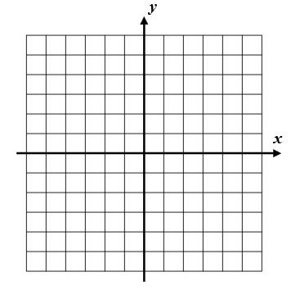

Example 1: Graph $y={(x+2)}^{\frac{1}{2}}-3$

Example 2: Graph $y=\frac{-1}{2}\sqrt{x-3}+1$

Graphing the Cube Root Function

Graph $y=x^{\frac{1}{3}}$

Examples:
1. Graph $y=2\sqrt[3]{x+1}-4$ 2. Graph $y=3-\frac{1}{2}\sqrt[3]{x-2}$

3. You can model the population P of Corpus Christi, Texas, between the years 1970 and 2005 by the radical function $P\left(x\right)=75,000\sqrt[3]{x-1950}$, where x is the year. Using this model, in what year was the population of Corpus Christi 250,000? Solve this both algebraically and graphically.

